

**3D Printed Thermoactive Quasi-Zero Stiffness Metamaterial Cell for Vibration Isolation**

Kuhljevi dnevi - report

**Authors:** G. Bizjan, J. Slavič

**Key words:** #Metamaterial #Quasi-ZeroStifness #VibrationIsolation #Transmissibility #3DPrinting #Termoactive #LowFrequency

**Bastract:**

In this paper, we present the design and research of a representative unit cell of a metamaterial designed for vibration isolation, using 3D printing. The unit cell incorporates a unique combination of a sinusoidal beam's snap-through behaviour and the bending-dominated support provided by two semi-circular arches, resulting in a quasi-zero stiffness property. The arches contribute to high static loads, while the bi-stable beams introduce negative stiffness, effectively reducing the overall stiffness of the cell and resulting in low dynamic stiffness. The use of a thermoactive conductive filament allows for adaptive control of stiffness and the adjustment of transmissibility through Joule heating. By selectively reducing the stiffness of the elements, different masses can be used just as effectively. Experiments and simulations are conducted to investigate the static characteristics of the unit cell and verify the theoretical solutions. Additionally, dynamic analysis of the cell under displacement is performed using theoretical, numerical, and experimental methods to study its vibration isolation performance via transmissibility. The results demonstrate that the properly designed unit cells can effectively achieve the desired quasi-zero stiffness property, leading to excellent vibration isolation performance. This metamaterial shows great potential for application in vibration isolation for small-scale equipment, where traditional spring mechanisms may be impractical. Moreover, the adaptive thermoactive nature of the cell enables it to adapt to environmental or load changes, further enhancing its performance characteristics.

Kazalo

1 Material Properties 2

2 RUC and its Static Analysis 4

3 Dynamic Analysis 6

4 Conclusion and continuation proposal 9

# Material Properties

A 3D printing filament such as a graphite laced TPU, has the capability of conducting electricity. Due to Joule heating, that results in the softening of the material and therefore in the change of it's module of elasticity and stiffness. **Currently we don't have the exact measured characteristics**, but only **an estimation** with which we did our simulations (simulation resuts in the later chapters). We assumed TPU fillament. Data gathered from Gašper Krivic.

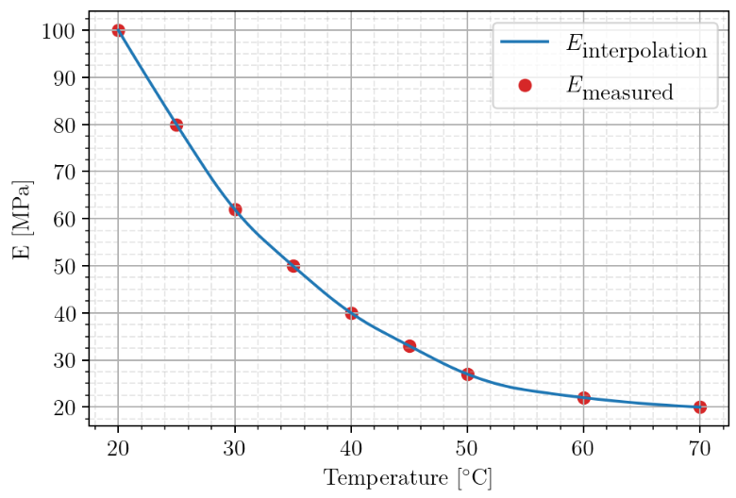

The problem is that this material model assmues linear and time stable characteristics. In reality we have a material that shows creep and is non-linear.

**Proposal:** Experimentally conduct tensile and compression test. We can make an in-house experiment and determine how the material changes with temperature and time.

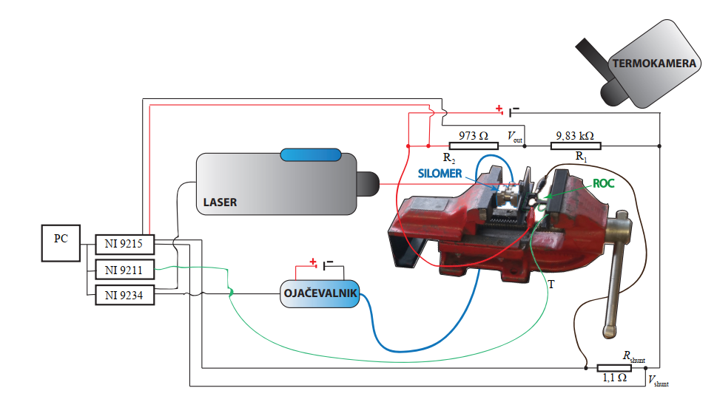

We can use **the laser** to measure the displacement coused by the **vise**. We can use **a force sensor** to measure tensile/compressive forces at different temperatures. The hating is done by the Jule effect and the temperature measured by **a thermocouple/camera**.

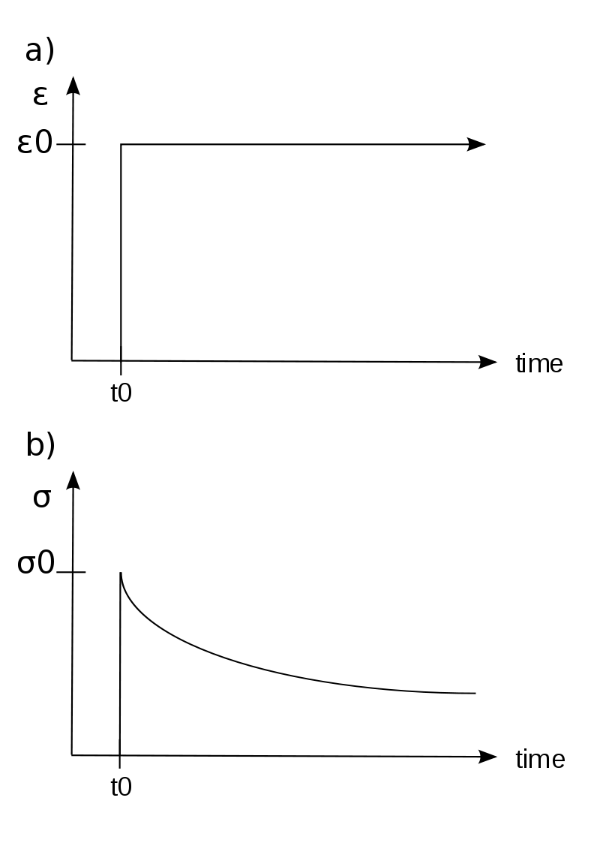

We will still limit ourselves to low deformations so we can assume a linear material and then define E(t, T) for our TPU material as an approximation. If we assume the modulus goes to a constant value as time passes on assympzhotically, we can define E(T). Having the correct E, we can formulate the design of the unit cell s seen in the next part.

# RUC and its Static Analysis

A representative unit cell (RUC) of a metamaterial (MM) is the most basic sub-structure within a metamaterial. We have a shape as seen here:



We have horizontal beams that cause buckling and jump-through. The most important characteristic is the non-linear **quasy-zero stiffness (QZS)** characteristic:

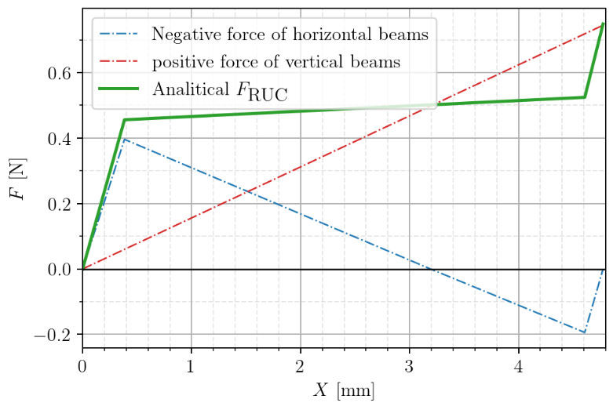

Quasi-zero stiffness (QZS) characteristic means a way to achieve a very low dynamic stiffness, while maintaining a high static stiffness. **We can carry high static masses but use low-stiffness vibration isolation, which is better**. For the proper formulation of a quasy-zero stiffness characteristic, we need an exact modulus E of the material used.

Now let's look at what we can accomplish by heating up the RUC. The following graph shows a Taylor approximation of the first graph at different temperatures.

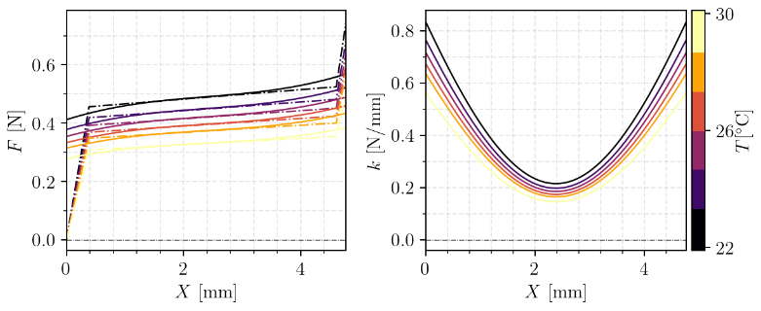

The overall force goes down as the stifness decreeses, but the characteristic of the QZS stiffness depends on the following:



Where *kp* is the vertical and *kn* is the horizontal beam stifness. In other words, even though we changed the material stiffness, the overall QZS region remains the same. The only thing that chages is the amount of mass we can carry. In other words, we have an adaptive spring, where we can remain in the QZS region even though we change the mass. That can be seen on this graph:

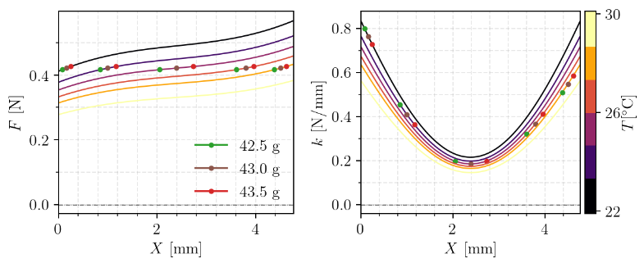

If we change the mass, the stifness will increase, since we are no longer in the flat QZS region. But by reducing/increasing the temperature, we also change the static carrying characteristic. Therefore we can adapt the spring to always stay in the QZS region.

Let's look why that is good in the next chapter.

# Dynamic Analysis

Transmissibility *T* is one of the most important parameters for measuring the performance of a a device for vibration isolation. Motion transmissibility is defined as the ratio of the magnitude of absolute displacement at the isolated mass to the absolute displacement at the base. We can define it as:

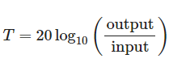

*T*>1 means amplification and maximum amplification occurs when forcing frequency of the system coincide. There is no unit designation for transmissibility. The lesser the transmissibility the better is the damping or the isolation system. *T*<1 is desirable, *T*=1 acts as a rigid body and *T*>1 is undesirable.

We derived analytical equations for the metamaterial with the QZS chaarcteristic and we can compare it to an equivalent linear spring (spring without the horizontal springs).

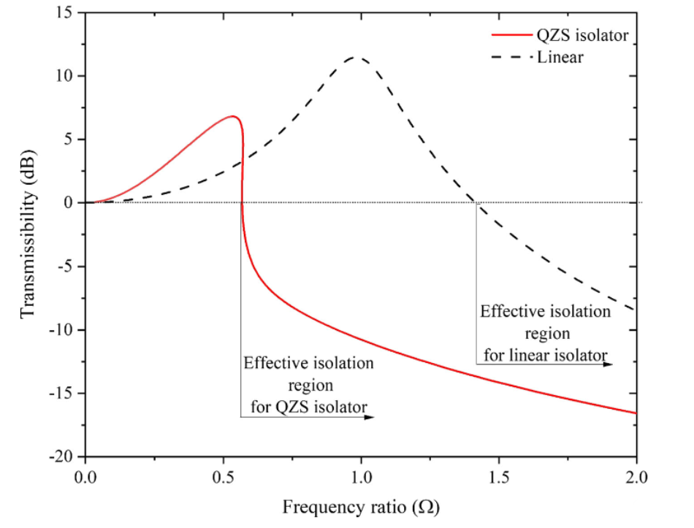

We can see how QZS isolator has a much larger effective region. But as we have seen increasing or decreesing the mass will change the region of stiffness and we will no longer be in the QZS region.

Let's look at the example where we change the mass, but also heat up the isolator.

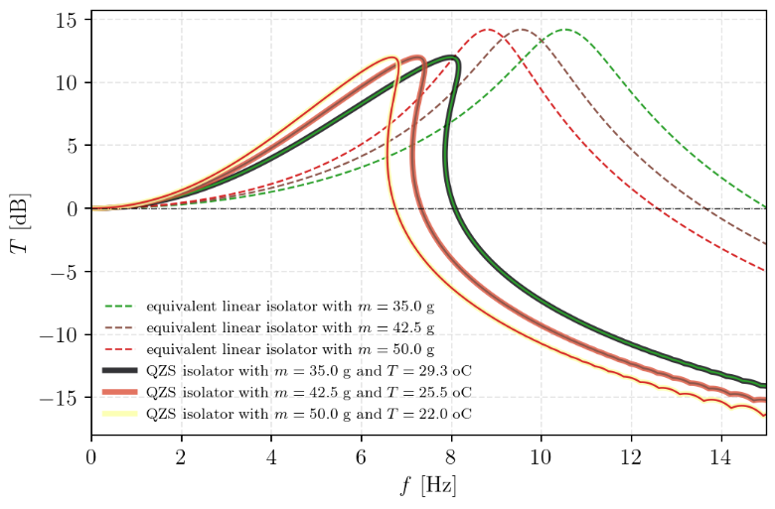

We can see how we stay inside the QZS region and keep the benefits, even though we had a changing mss of the laod *m*.

We have also done FEM analysis using the same material information and teh data is a fit.  
Currently in QZS region.

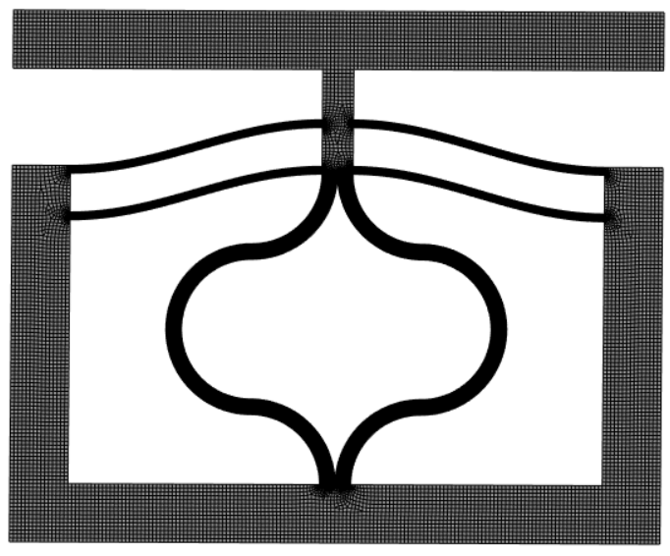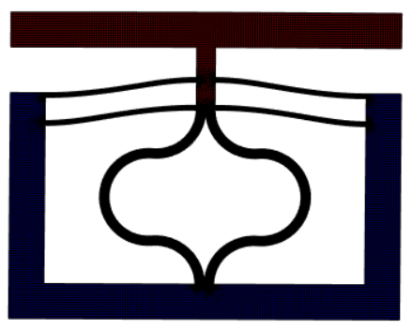

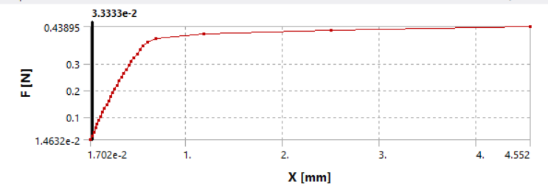

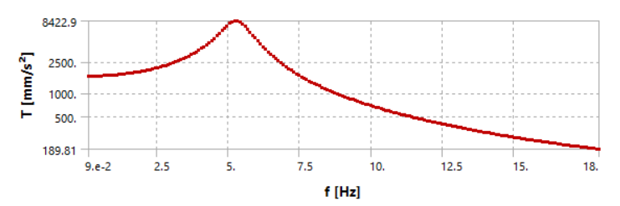

# Conclusion and continuation proposal

The simuations show and proove the potential use of an adaptive QZS isolator. The second step is to get the exact material data. I would like to use NinjaFlex TPU, and to the measurnments as desribed before. Using Joule heating and deformation we can determine modulus E at differnet temperatures an times.

After that we can design and print the final cell and do tests on it. Before the material is well understood, it is difficult to design a function QZS, since the design parameters much match.